**DAILY ONLINE ACTIVITIES SUMMARY**

|  |  |  |  |  |  |  |  |  |
| --- | --- | --- | --- | --- | --- | --- | --- | --- |
| **Date:** | **08/07/2020** | | | | | **Name:** | **Katira Krishna J** | |
| **Sem & Sec** | **8th A** | | | | | **USN:** | **4AL16CS045** | |
| **Online Test Summary** | | | | | | | | |
| **Subject** | | **-** | | | | | | |
| **Max. Marks** | | **-** | | **Score** | | | **-** | |
| **Certification Course Summary** | | | | | | | | |
| **Course** | **Data Science Methodology** | | | | | | | |
| **Certificate Provider** | | | **Cognitiveclass.ai** | | **Duration** | | | **5 hours** |
| **Coding Challenges** | | | | | | | | |
| **Problem Statement: Python program to display nodes of a linked list using recursion** | | | | | | | | |
| **Status: Completed** | | | | | | | | |
| **Uploaded the report in Github** | | | | | **Yes** | | | |
| **If yes Repository name** | | | | | **Krishna_Katira** | | | |
| **Uploaded the report in slack** | | | | | **Yes** | | | |

Online Test Details:

No test conducted

Certification Course Details:

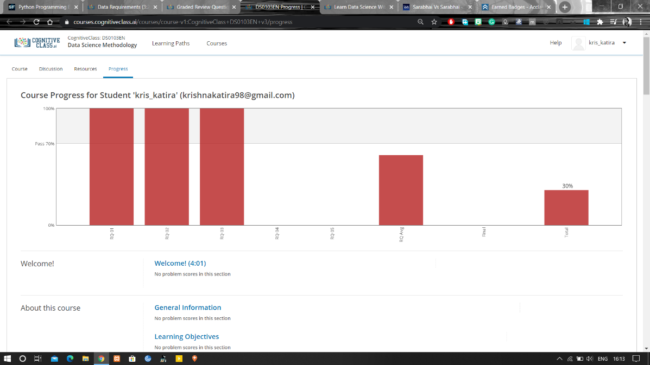

Coding Challenges Details:

**Program:**

class Node:

def __init__(self, data):

self.data = data

self.next = None

class LinkedList:

def __init__(self):

self.head = None

self.last_node = None

def append(self, data):

if self.last_node is None:

self.head = Node(data)

self.last_node = self.head

else:

self.last_node.next = Node(data)

self.last_node = self.last_node.next

def display(self):

self.display_helper(self.head)

def display_helper(self, current):

if current is None:

return

print(current.data, end = ' ')

self.display_helper(current.next)

a_llist = LinkedList()

n = int(input('How many elements would you like to add? '))

for i in range(n):

data = int(input('Enter data item: '))

a_llist.append(data)

print('The linked list: ', end = '')

a_llist.display()